CCNPv7 TSHOOT

Lab 3-1, Assembling Maintenance and Troubleshooting Tools
Physical Topology

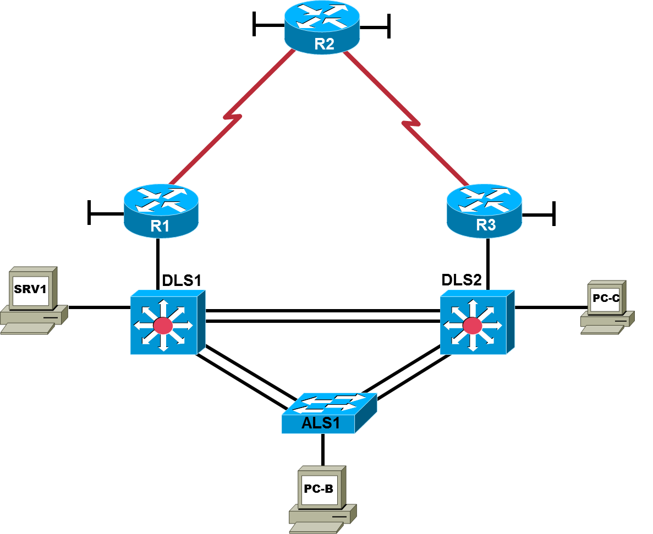

Objectives
- Assign responsibility for a device or set of devices to team members (optional).
- Load the baseline configuration for each device in the topology.
- Use available tools to document key device configuration parameters, such as the interfaces in use, IP addressing, routing protocols, VLANs, logging mechanisms, and security measures.
- Document the physical topology to support future troubleshooting tasks.
- Document the logical topology to support future troubleshooting tasks.

Background
You have been employed as a network engineering consultant by a company that has made a recent acquisition. The documentation for the acquired company’s network is incomplete and outdated, so you need to inventory their network architecture both logically and physically, per company documentation standards. This will help you learn about the design and implementation of their network and ensure that you have access to up-to-date and accurate network documentation to reference during future troubleshooting procedures. One directive to your predecessor was to transition access layer switches to multilayer switches, so static routing is implemented on the access layer switches until new multilayer switches are procured.
In this lab, you survey the baseline TSHOOT network. No problems are introduced in this lab. The TSHOOT network will evolve over time as changes and enhancements are made. You will analyze and document the current topology and device configuration parameters to develop familiarity with the baseline configurations and network connections. You will review and fill out the provided documentation as you analyze the network. You will assess and assemble tools that can be used for future maintenance and troubleshooting tasks.
Note: This lab uses Cisco ISR G2 routers running Cisco IOS 15.4(3) images with IP Base and Security packages enabled, and Cisco Catalyst 3560 and 2960 switches running Cisco IOS 15.0(2) IP Services and LAN Base images, respectively. The switches have Fast Ethernet interfaces, so the routing metrics for all Ethernet links in the labs are calculated based on 100 Mb/s, although the routers have Gigabit Ethernet interfaces. The 3560 and 2960 switches are configured with the SDM templates dual-ipv4-and-ipv6 routing and lanbase-routing, respectively. Depending on the router or switch model and Cisco IOS Software version, the commands available and output produced might vary from what is shown in this lab. Catalyst 3650 switches (running any Cisco IOS XE release) and Catalyst 2960-Plus switches (running any supported Cisco IOS image) can be used in place of the Catalyst 3560 switches and the Catalyst 2960 switches.

Required Resources
- 3 routers (Cisco IOS Release 15.4 or comparable)
- 2 multilayer switches and 1 access layer switch (Cisco IOS Release 15.0(2) or comparable with Fast Ethernet interfaces)
- SRV1 (PC with static IP address): Windows 7 with RADIUS, TFTP, and syslog servers, plus an SSH client, SNMP monitor, and WireShark.
- PC-B (DHCP client): Windows 7 with SSH client and WireShark software
- PC-C (DHCP client): Windows 7 with SSH client and WireShark software
- Serial and Ethernet cables, as shown in the topology
- Rollover cables to configure the routers and switches via the console

Task 1: Assign Responsibility for Each Device (optional)

Step 1: Review the lab topology together with your team members.

Step 2: Assign responsibility for each device to a team member.
- The team member who has primary responsibility for a device is in control of the console of that device and changes to that device. No other team member should access the console, make changes to the device, or execute disruptive actions, such as reloading or debugging, without permission from the responsible team member.
- All team members can access all devices via Telnet or SSH for non-disruptive diagnostic action without permission of the responsible team member. Responsibilities can be reassigned during later labs if necessary.
- If working in teams, document responsibilities in the Device Responsibilities table.
Device Responsibilities Table
Device | Description | Responsible Team Member
R1 | Core Router 1
R2 | ISP Router
R3 | Core Router 2
ALS1 | Access Layer Switch 1
DLS1 | Distribution Layer Switch 1
DLS2 | Distribution Layer Switch 2
SRV1 | TFTP, syslog, SNMP
PC-B | User PC
PC-C | User PC

Task 2: Load the Baseline Device Configuration Files
Use the following procedure on each device in the network to load the baseline configuration. The procedure shown here is for a switch, but it is very similar to that of a router.
Note: The configuration files for this lab include ip host name ip-addr entries for all devices. This can be helpful in accessing devices using Telnet with this lab. The ip host entries are only provided in this BASE lab, as the device IP addresses will change in subsequent labs.

Step 1: Verify the existence and location of the lab configuration files.
The course lab configuration files for a particular device should be in flash under the tshoot directory. Use the show flash command to verify the presence of this directory. You can also verify the contents of the directory using the cd and dir commands. If the directory and files are not present, contact your instructor.
Note: When the show flash command is used on a switch, it lists the directories and files at the root directory but not the files within the directories. The following example uses the cd and dir commands on switch ALS1.
ALS1# show flash

Directory of flash:/

9 -rwx 916 Feb 28 1993 16:04:03 -08:00 vlan.dat
3 drwx 512 Sep 22 2014 10:40:59 -07:00 tshoot
5 -rwx 11792247 Feb 28 1993 16:24:48 -08:00 c2960-lanbasek9-mz.150-2.SE6.bin
6 -rwx 7192 Sep 26 2014 10:53:31 -07:00 multiple-fs
7 -rwx 106 Feb 28 1993 18:13:09 -08:00 info
8 -rwx 1906 Sep 26 2014 10:53:31 -07:00 private-config.text
10 -rwx 7199 Sep 26 2014 10:53:31 -07:00 config.text

27998208 bytes total (16070656 bytes free)
ALS1# cd tshoot
ALS1# dir
Directory of flash:/tshoot/

9 -rwx 7979 Sep 22 2014 11:26:14 -07:00 BASE-ALS1-Cfg.txt
<output omitted>
Alternatively, you can see the contents of the directory by specifying its name using the dir command. For example:
ALS1# cd
ALS1# pwd
flash:
ALS1# dir flash:/tshoot
Directory of flash:/tshoot/

9 -rwx 7979 Sep 22 2014 11:26:14 -07:00 BASE-ALS1-Cfg.txt
<output omitted>
Note: When the show flash command is used on a router, it lists the directories and the files within them. The following example uses only the show flash command on router R1. The tshoot directory and its contents are listed.
R1# show flash:
-#- --length-- -----date/time------ path
1 103727964 Sep 18 2014 05:20:10 -07:00 c2900-universalk9-mz.SPA.154-3.M.bin
2 2857 Feb 22 2014 01:01:52 -08:00 pre_autosec.cfg
3 0 Sep 22 2014 11:39:18 -07:00 tshoot
4 3887 Sep 22 2014 11:42:20 -07:00 tshoot/BASE-R1-Cfg.txt
<output omitted>

Step 2: Erase startup-config from NVRAM, and then reset the SDM template.
ALS1# erase startup-config
Erasing the nvram filesystem will remove all configuration files! Continue? [confirm]
[OK]
Erase of nvram: complete
ALS1#
Sep 26 22:00:26.222: %SYS-7-NV_BLOCK_INIT: Initialized the geometry of nvram
ALS1# configure terminal
Enter configuration commands, one per line. End with CNTL/Z.
ALS1(config)# sdm prefer lanbase-routing
ALS1(config)#
Sep 26 22:00:45.155: %PARSER-5-CFGLOG_LOGGEDCMD: User:console logged command:sdm prefer lanbase-routing
ALS1(config)# exit
ALS1#
Sep 26 22:00:48.393: %SYS-5-CONFIG_I: Configured from console by console
ALS1# show sdm prefer
The current template is "lanbase-routing" template.
The selected template optimizes the resources in
the switch to support this level of features for
0 routed interfaces and 255 VLANs.

number of unicast mac addresses: 4K
number of IPv4 IGMP groups + multicast routes: 0.25K
number of IPv4 unicast routes: 4.25K
number of directly-connected IPv4 hosts: 4K
number of indirect IPv4 routes: 256
number of IPv6 multicast groups: 0.375k
number of IPv6 unicast routes: 1.25K
number of directly-connected IPv6 addresses: 0.75K
number of indirect IPv6 unicast routes: 448
number of IPv4 policy based routing aces: 0
number of IPv4/MAC qos aces: 0.125k
number of IPv4/MAC security aces: 0.375k
number of IPv6 policy based routing aces: 0
number of IPv6 qos aces: 0.375k
number of IPv6 security aces: 127

Note: For a 3560 switch, use the “dual-ipv4-and-ipv6 routing” template. If using another type of Cisco switch, choose an SDM template that supports IPv4/IPv6 routing and IPv4/IPv6 ACEs. The SDM setting reverts to the “default” template on a 2960 and the “desktop default” template on the 3560 after deleting startup-config, so it is important to change the SDM template setting after deleting startup-config. Most time-stamped logging messages, as seen in the output above, will be removed from the lab outputs going forward.

Step 3: Delete the VLAN database from flash (switches only).
ALS1# delete vlan.dat
Delete flash:/vlan.dat? [confirm]

Step 4: Reload the device, but do not save the system configuration if prompted.

ALS1# reload

System configuration has been modified. Save? [yes/no]: no

Proceed with reload? [confirm]

Step 5: When the device restarts, do not enter the initial configuration dialog.

Press RETURN to get started!

--- System Configuration Dialog ---

Enable secret warning

----------------------------------

In order to access the device manager, an enable secret is required

If you enter the initial configuration dialog, you will be prompted for the enable secret

If you choose not to enter the intial configuration dialog, or if you exit setup without setting the enable secret,

please set an enable secret using the following CLI in configuration mode-

enable secret 0 <cleartext password>

----------------------------------

Would you like to enter the initial configuration dialog? [yes/no]: no
Note: On some platform/IOS combinations, a message appears after choosing not to enter the initial configuration dialog, asking whether or not to “terminate autoinstall”. If this message appears, enter yes to terminate autoinstall.

Step 6: Copy the specified lab device configuration file from flash to running-config.
Switch> enable
Switch# copy flash:/tshoot/BASE-ALS1-Cfg.txt running-config
Destination filename [running-config]?

Note: Although it is possible to copy the file to startup-config and reload the device, the RSA keys for SSH cannot be generated from the startup-config file. The device configuration files loaded from flash contain commands that remove any existing keys and create new keys.
It is also possible to cut-and-paste the

Step 7: Copy the running config to the startup config.
Depending on the platform/IOS combination, AUTOSAVE may automatically save a copy of running-config to NVRAM for startup. AUTOSAVE does not copy the console line and vty line configurations from running-config to startup-config. To ensure that the startup configuration is complete, manually copy:
ALS1# copy running-config startup-config
Building configuration...
[OK]
Note: If the device is rebooted at this point, you can log in with the username cisco and the password cisco. To access privileged EXEC mode, use the enable secret: cisco.

Step 8: Repeat Steps 1 through 7 for the other devices in the network.

Step 9: Configure the PCs.
- Configure SRV1 with the static IPv4 address 10.1.100.1/24 and default gateway 10.1.100.254 (on DLS1). Configure SRV1 with the static IPv6 address 2001:DB8:CAFE:100::1 and default gateway 2001:DB8:CAFE:100::D1 (on DLS1).
- Configure PC-B and PC-C as DHCP clients for both IPv4 and IPv6.
Note: Make sure the PC’s learn addresses of the form 2001:DB8:CAFE:x:ABCD:u:v:w where x is the VLAN for the respective PC. Use ipconfig/release6 followed by ipconfig/renew6 to release and renew the stateful IPv6 data. If necessary, reset the NIC. The SVI commands for VLANs 110, 120, and 200,
ipv6 nd prefix 2001:DB8:CAFE:x::/64 no-autoconfig
ipv6 nd managed-config-flag
set the IPv6 RA M, O, and A flags so that the Windows 7 stateful DHCPv6 clients populate a singular GUA and appropriate link-local default routes, as seen in the ipconfig and route print outputs.

Step 10: Test basic network connectivity between devices.
- Ping from PC-B to SRV1 at 10.1.100.1 and 2001:DB8:CAFE:100::1. Were the pings successful?

- Ping from ALS1 to R2 Lo1 at 2.2.2.2 and 2001:DB8:EFAC::2. Were the pings successful?

Note: If the pings are not successful, contact your instructor.

Task 3: Analyze and Document the Physical Lab Topology
Note: At this time, only examine and document the physical connections. Documenting the logical topology, such as subnets, IP addresses, and routing protocols, is addressed in Task 4 of this lab.

Step 1: Review the physical topology diagram on page 1 of the lab.

Step 2: Use Cisco Discovery Protocol and show commands to verify the Layer 1 and Layer 2 connections of the lab topology.
- Use the show cdp command to discover the interfaces associated with the physical connections. Fill in the correct device and interface designators in the following Device Links table and label them on the physical topology diagram on the first page of the lab.
- Review the configurations of the devices for using Layer 1 and Layer 2 features, such as trunks and EtherChannels. Fill in the information in the Device Links table and add it to the diagram. If a link is accounted for from one device to another, it is not necessary to repeat the entry from the other device. The first entry for ALS1, interface F0/1 is filled in as an example.
Which other commands could you use to identify Layer 1 and Layer 2 characteristics?

Device Links Table

From Device | Interface | To Device | Interface | Layer 1 and 2 Features and Protocols Used
ALS1 | F0/1 | DLS1 | F0/1 | EtherChannel Po1, 802.1Q
- Verify that all physical links shown in the diagram are operational. Which commands did you use?

Step 3: Map the VLANs used in the lab to the devices in the diagram.
Fill in the VLAN Definition table and label the physical topology diagram with the VLANs used for this topology. Identify all host devices that are members of each VLAN. The first entry for VLAN 99 is filled in as an example.
VLAN Definition Table
VLAN # | Name | Description | VLAN Members
99 | MANAGEMENT | Management VLAN | ALS1, DLS1, DLS2

Step 4: Analyze spanning tree for the Layer 2 switched domain.
- Analyze the spanning tree characteristics of the Layer 2 switched portion of the network. Which type of spanning-tree mode is implemented?

- Which switch is the root switch for each VLAN, and what are the configured spanning-tree priorities?

- What is the resulting spanning-tree topology for VLANs that have client devices connected?

- Which commands did you use to analyze the spanning-tree characteristics?

Step 5: Diagram the spanning tree for VLAN 120.
- Label the STP role and port status for each port channel used in the physical topology diagram below.
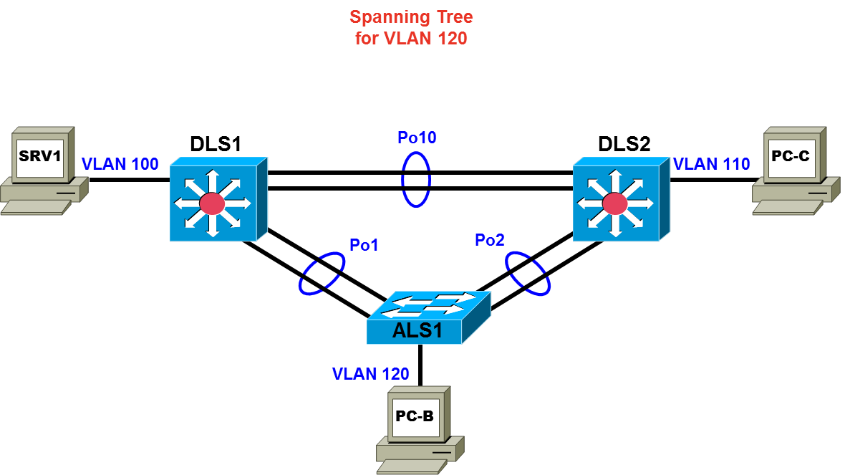

- If working as a team, discuss your findings with your teammates to ensure that all team members understand the physical and data link aspects of the network design.

Student Notes
Use this space to make any additional notes regarding the physical configuration and the commands used.

Task 4: Analyze and Document the Logical Lab Topology

Step 1: Review the logical lab diagram and the subnets.
Review the IP subnets in the Subnet table for the VLANs and WAN links that are used in the lab network. Router interface designations from the physical topology diagram are provided in two copies of the logical topology, one to be used for IPv4 data and one for IPv6 data.

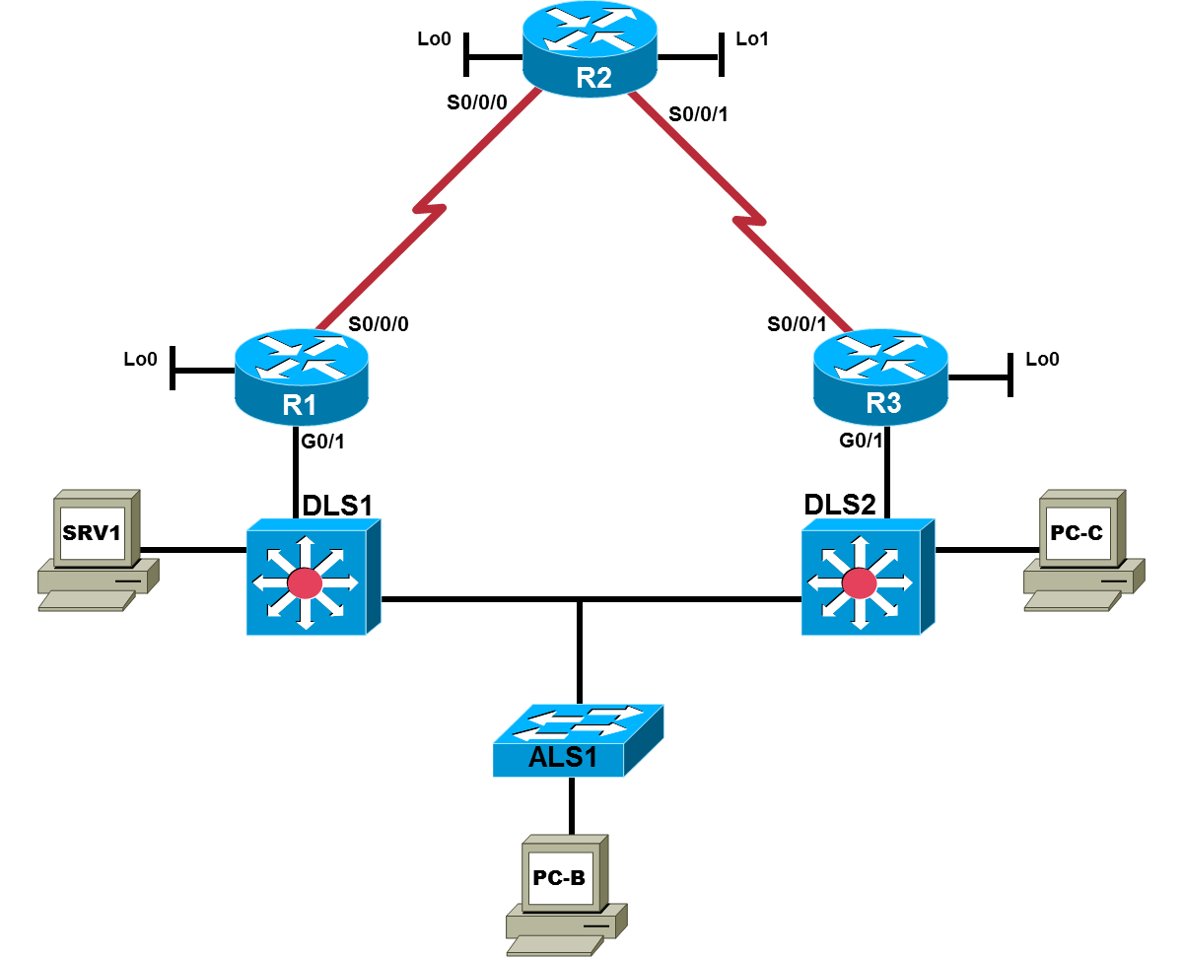

Subnet Table
Description | IPv4 Subnet | IPv6 Prefix | Devices
VLANs
Management VLAN 99 | 10.1.99.0/24 | 2001:DB8:CAFE:99::/64 | ALS1,DLS1,DLS2
Servers VLAN 100 | 10.1.100.0/24 | 2001:DB8:CAFE:100::/64 | SRV1
Guest VLAN 110 | 10.1.110.0/24 | 2001:DB8:CAFE:110::/64 | PC-C
Office VLAN 120 | 10.1.120.0/24 | 2001:DB8:CAFE:120::/64 | PC-B
Management VLAN | 10.1.99.0/24 | 2001:DB8:CAFE:200::/64 | ALS1, DLS1, DLS2
WAN Links
DLS1 – R1 | 10.1.2.0/30 | 2001:DB8:CAFE:20::/64 | DLS1 and R1 GE link
DLS2 – R3 | 10.1.2.12/30 | 2001:DB8:CAFE:212::/64 | DLS2 and R3 GE link
R1 – R2 | 10.1.1.0/30 | 2001:DB8:CAFE:10::/64 | R1 and R2 serial link
R2 – R3 | 10.1.1.4/30 | 2001:DB8:CAFE:14::/64 | R2 and R3 serial link
Step 2: Map the subnet scheme to the logical diagram.
In the previous step, the subnets were documented in the Subnet table. Now document the host portion of the addresses. To document the host part, research the routing tables and interface IP addresses of all the devices. Document the interface IPv4 and IPv6 addresses in the IP Address table and on the associated logical topology diagram. Use only the number of the last octet for IPv4 addresses and the last hextet for IPv6 addresses in the respective diagrams. The device names and interfaces are listed to help identify the IP addresses. The entry for ALS1 VLAN 99 is shown as an example. If an interface is not in use, indicate this in the Additional Information column. Account for all physical and virtual interfaces.
IP Address Table
Device Name | Interface | IPv4 Address/Prefix | IPv6 Address/Prefix | Additional Information
ALS1 | Vlan 99 | 10.1.99.251/24 | 2001:DB8:CAFE:99::A1/64 | SVI
ALS1 | Vlan 110
ALS1 | Vlan 120
ALS1 | Vlan 200
DLS1 | Vlan 99
DLS1 | Vlan 100
DLS1 | Vlan 110
DLS1 | Vlan 120
DLS1 | Vlan 200
DLS1 | F0/5
DLS2 | Vlan 99
DLS2 | Vlan 100
DLS2 | Vlan 110
DLS2 | Vlan 120
DLS2 | Vlan 200
DLS2 | F0/5
R1 | G0/0
R1 | G0/1
R1 | S0/0/0
R1 | S0/0/1
R1 | Loopback 0
R2 | G0/0
R2 | G0/1
R2 | S0/0/0
R2 | S0/0/1
R2 | Loopback 0
R2 | Loopback 1
R3 | G0/0
R3 | G0/1
R3 | S0/0/0
R3 | S0/0/1
R3 | Loopback 0
SRV1 | NIC
PC-B | NIC
PC-C | NIC

Step 3: Analyze and document control plane logical configuration features.
Analyze the configurations of the devices for control plane features such as routing protocols, First Hop Redundancy Protocols (FHRPs), dynamic host configuration protocol (DHCP), and network address translation (NAT). Review, document, and discuss the following aspects of the logical network configuration.
- Is dynamic or static routing being used?

- If dynamic, which routing protocol?

- Are FHRPs in use, such as the Hot Standby Router Protocol (HSRP), Virtual Router Redundancy Protocol (VRRP), or Gateway Load Balancing Protocol (GLBP)? If yes, which one?

- What is the active router for all relevant VLANs?

- From the PC-B command prompt, issue the tracert command to router R2 Lo0 at 10.1.202.1 for IPv4 and 2001:DB8:CAFE:202:2 for IPv6. What path did the packets take in each case?

- Are any access lists used to filter traffic on the network? If yes, describe their function.

- Is DHCP in use? If yes, which DHCP server is used and for which VLANs present in the logical topology diagram?

- How does ALS1 send ICMP echo requests to SRV1 in VLAN 100, when ALS1 has no VLAN 100?

- If working as a team, discuss your findings with your teammates to ensure that all team members understand the high-level design of the network.
Notes
Use this space to make any additional notes regarding the logical configuration and the commands used.

Task 5: Identify Troubleshooting and Maintenance Tools

Step 1: Analyze device configurations for troubleshooting and maintenance features.
Analyze the configurations of the devices for services that support troubleshooting and maintenance, such as syslog, Simple Network Management Protocol (SNMP), and other network management features.

Step 2: Document the troubleshooting and maintenance features.
- Document the troubleshooting and maintenance applications or tools in use with the network devices in the Troubleshooting and Maintenance Tools table. An entry for system logging is provided as an example.

Troubleshooting and Maintenance Tools Table
Configured Feature | Devices | Target Server | Target Tool or Application
System message logging | All | SRV1 | Syslog server
- If working as a team, discuss your findings with your teammates to ensure that all team members know which maintenance and troubleshooting tools are available in the network.

Notes
Use this space to make any additional notes regarding troubleshooting and maintenance applications or tools.

Task 6: Identify the Security Measures Implemented

Step 1: Analyze device configurations for security-related features.
Analyze the configurations of your assigned devices for configuration options that help support a more secure network implementation, such as password security, login authentication, secure remote management, switch trunk and access port security, and VLANs. Record your entries in the Security Features table. An entry for password security is provided as an example.
Security Features Table
Security Feature Configured | Implementation Method or Commands
Password security | Enable secret, password encryption

Notes
Use this space to make any additional notes regarding security measures.

Note: Configuration command sequences for all devices are provided at the end of the lab. These are not outputs resulting from entering the show running-config command. Only the non-default commands used to configure the devices are included (along with no shutdown on appropriate interfaces).

Lab Debrief Notes
Use this space to make notes regarding the key concepts learned during the lab debrief discussions with your instructor. This may include alternate solutions, methods, and processes; this may include procedure and communication improvements; and this may include key commands and tools.
Note: This is your primary opportunity to document a baseline of the lab network before starting the troubleshooting exercises. During the debrief session, ask your instructor for clarification of any aspects of the network design and configurations that are unclear.

Device Configurations
Switch ALS1
!BASE ALS1 Config
!
service timestamps debug datetime msec
service timestamps log datetime msec
service password-encryption
!
hostname ALS1
!
logging buffered 16384
enable secret cisco
!
username cisco secret cisco
aaa new-model
!
!
aaa authentication login default local
aaa authentication login CONSOLE none
aaa authorization exec default local
!
!
clock timezone PST -8
clock summer-time PDT recurring
system mtu routing 1500
vtp domain TSHOOT
vtp mode transparent
ip routing
!
!
no ip domain-lookup
ip domain-name tshoot.net
ip host R1 10.1.2.2 10.1.1.1 10.1.201.1
ip host R2 10.1.1.2 10.1.1.6 10.1.202.1
ip host R3 10.1.1.5 10.1.2.14 10.1.203.1
ip host ALS1 10.1.99.1
ip host DLS1 10.1.99.252 10.1.2.1
ip host DLS2 10.1.99.253 10.1.2.13
ipv6 unicast-routing
!
errdisable recovery cause psecure-violation
errdisable recovery interval 120
!
spanning-tree mode rapid-pvst
spanning-tree portfast default
spanning-tree extend system-id
!
vlan 99
name MANAGEMENT
!
vlan 110
name GUEST
!
vlan 120
name OFFICE
!
vlan 200
name VOICE
!
vlan 666
name NATIVE
!
vlan 999
name PARKING_LOT
!
ip telnet source-interface Vlan99
ip ssh source-interface Vlan99
!
!
interface Port-channel1
description Channel to DLS1
switchport trunk native vlan 666
switchport trunk allowed vlan 99,110,120,200
switchport mode trunk
switchport nonegotiate
no shutdown
!
interface Port-channel2
description Channel to DLS2
switchport trunk native vlan 666
switchport trunk allowed vlan 99,110,120,200
switchport mode trunk
switchport nonegotiate
no shutdown
!
interface FastEthernet0/1
description Channel to DLS1
switchport trunk native vlan 666
switchport trunk allowed vlan 99,110,120,200
switchport mode trunk
switchport nonegotiate
channel-group 1 mode on
no shutdown
!
interface FastEthernet0/2
description Channel to DLS1
switchport trunk native vlan 666
switchport trunk allowed vlan 99,110,120,200
switchport mode trunk
switchport nonegotiate
channel-group 1 mode on
no shutdown
!
interface FastEthernet0/3
description Channel to DLS2
switchport trunk native vlan 666
switchport trunk allowed vlan 99,110,120,200
switchport mode trunk
switchport nonegotiate
channel-group 2 mode on
no shutdown
!
interface FastEthernet0/4
description Channel to DLS2
switchport trunk native vlan 666
switchport trunk allowed vlan 99,110,120,200
switchport mode trunk
switchport nonegotiate
channel-group 2 mode on
no shutdown
!
interface FastEthernet0/5
description PARKING_LOT
switchport access vlan 999
switchport mode access
switchport nonegotiate
shutdown
!
interface FastEthernet0/6
description PARKING_LOT
switchport access vlan 999
switchport mode access
switchport nonegotiate
shutdown
!
interface FastEthernet0/7
description PARKING_LOT
switchport access vlan 999
switchport mode access
switchport nonegotiate
shutdown
!
interface FastEthernet0/8
description PARKING_LOT
switchport access vlan 999
switchport mode access
switchport nonegotiate
shutdown
!
interface FastEthernet0/9
description PARKING_LOT
switchport access vlan 999
switchport mode access
switchport nonegotiate
shutdown
!
interface FastEthernet0/10
description PARKING_LOT
switchport access vlan 999
switchport mode access
switchport nonegotiate
shutdown
!
interface FastEthernet0/11
description PARKING_LOT
switchport access vlan 999
switchport mode access
switchport nonegotiate
shutdown
!
interface FastEthernet0/12
description PARKING_LOT
switchport access vlan 999
switchport mode access
switchport nonegotiate
shutdown
!
interface FastEthernet0/13
description PARKING_LOT
switchport access vlan 999
switchport mode access
switchport nonegotiate
shutdown
!
interface FastEthernet0/14
description PARKING_LOT
switchport access vlan 999
switchport mode access
switchport nonegotiate
shutdown
!
interface FastEthernet0/15
description PARKING_LOT
switchport access vlan 999
switchport mode access
switchport nonegotiate
shutdown
!
interface FastEthernet0/16
description PARKING_LOT
switchport access vlan 999
switchport mode access
switchport nonegotiate
shutdown
!
interface FastEthernet0/17
description PARKING_LOT
switchport access vlan 999
switchport mode access
switchport nonegotiate
shutdown
!
interface FastEthernet0/18
description To PC-B
switchport access vlan 120
switchport mode access
switchport voice vlan 200
switchport port-security maximum 3
switchport port-security
switchport port-security mac-address sticky
spanning-tree portfast
no shutdown
!
interface FastEthernet0/19
description PARKING_LOT
switchport access vlan 999
switchport mode access
switchport nonegotiate
shutdown
!
interface FastEthernet0/20
description PARKING_LOT
switchport access vlan 999
switchport mode access
switchport nonegotiate
shutdown
!
interface FastEthernet0/21
description PARKING_LOT
switchport access vlan 999
switchport mode access
switchport nonegotiate
shutdown
!
interface FastEthernet0/22
description PARKING_LOT
switchport access vlan 999
switchport mode access
switchport nonegotiate
shutdown
!
interface FastEthernet0/23
description PARKING_LOT
switchport access vlan 999
switchport mode access
switchport nonegotiate
shutdown
!
interface FastEthernet0/24
description PARKING_LOT
switchport access vlan 999
switchport mode access
switchport nonegotiate
shutdown
!
interface GigabitEthernet0/1
description PARKING_LOT
switchport access vlan 999
switchport mode access
switchport nonegotiate
shutdown
!
interface GigabitEthernet0/2
description PARKING_LOT
switchport access vlan 999
switchport mode access
switchport nonegotiate
shutdown
!
interface Vlan1
no ip address
shutdown
!
interface Vlan99
ip address 10.1.99.251 255.255.255.0
ipv6 address FE80::A1 link-local
ipv6 address 2001:DB8:CAFE:99::A1/64
no shutdown
!
interface Vlan110
ip address 10.1.110.251 255.255.255.0
ipv6 address FE80::A1 link-local
ipv6 address 2001:DB8:CAFE:110::A1/64
ipv6 nd prefix 2001:DB8:CAFE:110::/64 no-autoconfig
ipv6 nd managed-config-flag
no shutdown
!
interface Vlan120
ip address 10.1.120.251 255.255.255.0
ipv6 address FE80::A1 link-local
ipv6 address 2001:DB8:CAFE:120::A1/64
ipv6 nd prefix 2001:DB8:CAFE:120::/64 no-autoconfig
ipv6 nd managed-config-flag
no shutdown
!
interface Vlan200
ip address 10.1.200.251 255.255.255.0
ipv6 address FE80::A1 link-local
ipv6 address 2001:DB8:CAFE:200::A1/64
ipv6 nd prefix 2001:DB8:CAFE:200::/64 no-autoconfig
ipv6 nd managed-config-flag
no shutdown
!
crypto key gen rsa general-keys modulus 1024
!
no ip http server
no ip http secure-server
ip route 0.0.0.0 0.0.0.0 10.1.99.254
logging source-interface Vlan99
logging host 10.1.100.1
ipv6 route ::/0 2001:DB8:CAFE:99::D1
!
snmp-server community cisco RO
snmp-server community san-fran RW
snmp-server trap-source Vlan99
snmp-server location TSHOOT Lab Facility
snmp-server contact support@tshoot.net
snmp-server enable traps vtp
snmp-server enable traps vlancreate
snmp-server enable traps vlandelete
snmp-server enable traps port-security
snmp-server enable traps vlan-membership
snmp-server host 10.1.100.1 version 2c cisco
!
!
banner motd ^*** BASE ALS1 Config ***^
!
ipv6 access-list REMOTEv6
deny ipv6 any any
!
line con 0
exec-timeout 0 0
logging synchronous
login authentication CONSOLE
line vty 0 4
exec-timeout 0 0
ipv6 access-class REMOTEv6 in
logging synchronous
length 0
transport input telnet ssh
!
ntp source Vlan99
ntp server 10.1.202.1
!
archive
log config
logging enable
logging size 50
notify syslog contenttype plaintext
hidekeys
path tftp://10.1.100.1/$h-archive-config
file prompt quiet
!
end
!
Switch DLS1
!BASE DLS1 Config
!
service timestamps debug datetime msec
service timestamps log datetime msec
service password-encryption
!
hostname DLS1
!
!
logging buffered 16384
enable secret cisco
!
username cisco secret cisco
aaa new-model
!
!
aaa authentication login default local
aaa authentication login CONSOLE none
aaa authorization exec default local
!
!
clock timezone PST -8
clock summer-time PDT recurring
system mtu routing 1500
vtp domain TSHOOT
vtp mode transparent
ip routing
no ip domain-lookup
ip domain-name tshoot.net
ip host R1 10.1.2.2 10.1.1.1 10.1.201.1
ip host R2 10.1.1.2 10.1.1.6 10.1.202.1
ip host R3 10.1.1.5 10.1.2.14 10.1.203.1
ip host ALS1 10.1.99.251
ip host DLS1 10.1.99.252 10.1.2.1
ip host DLS2 10.1.99.253 10.1.2.13
!
ip dhcp excluded-address 10.1.120.251 10.1.120.254
ip dhcp excluded-address 10.1.200.251 10.1.200.254
ip dhcp excluded-address 10.1.110.251 10.1.110.254
!
ip dhcp pool VOICE
network 10.1.200.0 255.255.255.0
default-router 10.1.200.254
!
ip dhcp pool GUEST
network 10.1.110.0 255.255.255.0
default-router 10.1.110.254
!
ip dhcp pool OFFICE
network 10.1.120.0 255.255.255.0
default-router 10.1.120.254
!
!
ipv6 unicast-routing
ipv6 dhcp pool DHCPv6OFFICE
address prefix 2001:DB8:CAFE:120:ABCD::/80
domain-name tshoot.net
!
ipv6 dhcp pool DHCPv6VOICE
address prefix 2001:DB8:CAFE:200:ABCD::/80
domain-name tshoot.net
!
ipv6 dhcp pool DHCPv6GUEST
address prefix 2001:DB8:CAFE:110:ABCD::/80
domain-name tshoot.net
!
!
errdisable recovery cause bpduguard
!
spanning-tree mode rapid-pvst
spanning-tree extend system-id
spanning-tree vlan 99,110,120 priority 24576
spanning-tree vlan 100,200 priority 28672
!
!
vlan 99
name MANAGEMENT
!
vlan 100
name SERVERS
!
vlan 110
name GUEST
!
vlan 120
name OFFICE
!
vlan 200
name VOICE
!
vlan 666
name NATIVE
!
vlan 999
name PARKING_LOT
!
ip telnet source-interface Vlan99
ip ssh source-interface Vlan99
!
!
interface Port-channel1
description Channel to ALS1
switchport trunk encapsulation dot1q
switchport trunk native vlan 666
switchport trunk allowed vlan 99,110,120,200
switchport mode trunk
switchport nonegotiate
no shutdown
!
interface Port-channel10
description Channel to DLS2
switchport trunk encapsulation dot1q
switchport trunk native vlan 666
switchport trunk allowed vlan 99,100,110,120,200
switchport mode trunk
switchport nonegotiate
no shutdown
!
interface FastEthernet0/1
description Channel to ALS1
switchport trunk encapsulation dot1q
switchport trunk native vlan 666
switchport trunk allowed vlan 99,110,120,200
switchport mode trunk
switchport nonegotiate
channel-group 1 mode on
no shutdown
!
interface FastEthernet0/2
description Channel to ALS1
switchport trunk encapsulation dot1q
switchport trunk native vlan 666
switchport trunk allowed vlan 99,110,120,200
switchport mode trunk
switchport nonegotiate
channel-group 1 mode on
no shutdown
!
interface FastEthernet0/3
description Channel to DLS2
switchport trunk encapsulation dot1q
switchport trunk native vlan 666
switchport trunk allowed vlan 99,100,110,120,200
switchport mode trunk
switchport nonegotiate
channel-group 10 mode on
no shutdown
!
interface FastEthernet0/4
description Channel to DLS2
switchport trunk encapsulation dot1q
switchport trunk native vlan 666
switchport trunk allowed vlan 99,100,110,120,200
switchport mode trunk
switchport nonegotiate
channel-group 10 mode on
no shutdown
!
interface FastEthernet0/5
description FE to R1
no switchport
ip address 10.1.2.1 255.255.255.252
speed 100
duplex full
ipv6 address FE80::D1 link-local
ipv6 address 2001:DB8:CAFE:20::D1/64
ipv6 eigrp 1
spanning-tree bpduguard enable
no shutdown
!
interface FastEthernet0/6
description FE to SRV1
switchport access vlan 100
switchport mode access
switchport nonegotiate
spanning-tree portfast
!
interface FastEthernet0/7
description PARKING_LOT
switchport access vlan 999
switchport mode access
switchport nonegotiate
shutdown
!
interface FastEthernet0/8
description PARKING_LOT
switchport access vlan 999
switchport mode access
switchport nonegotiate
shutdown
!
interface FastEthernet0/9
description PARKING_LOT
switchport access vlan 999
switchport mode access
switchport nonegotiate
shutdown
!
interface FastEthernet0/10
description PARKING_LOT
switchport access vlan 999
switchport mode access
switchport nonegotiate
shutdown
!
interface FastEthernet0/11
description PARKING_LOT
switchport access vlan 999
switchport mode access
switchport nonegotiate
shutdown
!
interface FastEthernet0/12
description PARKING_LOT
switchport access vlan 999
switchport mode access
switchport nonegotiate
shutdown
!
interface FastEthernet0/13
description PARKING_LOT
switchport access vlan 999
switchport mode access
switchport nonegotiate
shutdown
!
interface FastEthernet0/14
description PARKING_LOT
switchport access vlan 999
switchport mode access
switchport nonegotiate
shutdown
!
interface FastEthernet0/15
description PARKING_LOT
switchport access vlan 999
switchport mode access
switchport nonegotiate
shutdown
!
interface FastEthernet0/16
description PARKING_LOT
switchport access vlan 999
switchport mode access
switchport nonegotiate
shutdown
!
interface FastEthernet0/17
description PARKING_LOT
switchport access vlan 999
switchport mode access
switchport nonegotiate
shutdown
!
interface FastEthernet0/18
description PARKING_LOT
switchport access vlan 999
switchport mode access
switchport nonegotiate
shutdown
!
interface FastEthernet0/19
description PARKING_LOT
switchport access vlan 999
switchport mode access
switchport nonegotiate
shutdown
!
interface FastEthernet0/20
description PARKING_LOT
switchport access vlan 999
switchport mode access
switchport nonegotiate
shutdown
!
interface FastEthernet0/21
description PARKING_LOT
switchport access vlan 999
switchport mode access
switchport nonegotiate
shutdown
!
interface FastEthernet0/22
description PARKING_LOT
switchport access vlan 999
switchport mode access
switchport nonegotiate
shutdown
!
interface FastEthernet0/23
description PARKING_LOT
switchport access vlan 999
switchport mode access
switchport nonegotiate
shutdown
!
interface FastEthernet0/24
description PARKING_LOT
switchport access vlan 999
switchport mode access
switchport nonegotiate
shutdown
!
interface GigabitEthernet0/1
description PARKING_LOT
switchport access vlan 999
switchport mode access
switchport nonegotiate
shutdown
!
interface GigabitEthernet0/2
description PARKING_LOT
switchport access vlan 999
switchport mode access
switchport nonegotiate
shutdown
!
interface Vlan1
no ip address
shutdown
!
interface Vlan99
ip address 10.1.99.252 255.255.255.0
standby 99 ip 10.1.99.254
standby 99 priority 110
standby 99 preempt
ipv6 address FE80::D1 link-local
ipv6 address 2001:DB8:CAFE:99::D1/64
ipv6 eigrp 1
no shutdown
!
interface Vlan100
ip address 10.1.100.252 255.255.255.0
standby 100 ip 10.1.100.254
standby 100 preempt
ipv6 address FE80::D1 link-local
ipv6 address 2001:DB8:CAFE:100::D1/64
ipv6 eigrp 1
no shutdown
!
interface Vlan110
ip address 10.1.110.252 255.255.255.0
standby 110 ip 10.1.110.254
standby 110 priority 110
standby 110 preempt
ipv6 address FE80::D1 link-local
ipv6 address 2001:DB8:CAFE:110::D1/64
ipv6 nd prefix 2001:DB8:CAFE:110::/64 no-autoconfig
ipv6 nd managed-config-flag
ipv6 eigrp 1
ipv6 dhcp server DHCPv6GUEST
no shutdown
!
interface Vlan120
ip address 10.1.120.252 255.255.255.0
standby 120 ip 10.1.120.254
standby 120 priority 110
standby 120 preempt
ipv6 address FE80::D1 link-local
ipv6 address 2001:DB8:CAFE:120::D1/64
ipv6 nd prefix 2001:DB8:CAFE:120::/64 no-autoconfig
ipv6 nd managed-config-flag
ipv6 eigrp 1
ipv6 dhcp server DHCPv6OFFICE
no shutdown
!
interface Vlan200
ip address 10.1.200.252 255.255.255.0
standby 200 ip 10.1.200.254
standby 200 preempt
ipv6 address FE80::D1 link-local
ipv6 address 2001:DB8:CAFE:200::D1/64
ipv6 nd prefix 2001:DB8:CAFE:200::/64 no-autoconfig
ipv6 nd managed-config-flag
ipv6 eigrp 1
ipv6 dhcp server DHCPv6VOICE
no shutdown
!
!
router eigrp 1
network 10.1.0.0 0.0.255.255
passive-interface default
no passive-interface FastEthernet0/5
no passive-interface Vlan99
no passive-interface Vlan100
no passive-interface Vlan110
no passive-interface Vlan120
no passive-interface Vlan200
!
crypto key gen rsa general-keys modulus 1024
!
no ip http server
no ip http secure-server
!
!
logging source-interface Vlan99
logging host 10.1.100.1
ipv6 router eigrp 1
eigrp router-id 1.1.1.1
!
!
snmp-server community cisco RO
snmp-server community san-fran RW
snmp-server trap-source Vlan99
snmp-server location TSHOOT Lab Facility
snmp-server contact support@tshoot.net
snmp-server enable traps eigrp
snmp-server enable traps vtp
snmp-server enable traps vlancreate
snmp-server enable traps vlandelete
snmp-server enable traps port-security
snmp-server enable traps config
snmp-server enable traps hsrp
snmp-server enable traps vlan-membership
snmp-server enable traps errdisable
snmp-server host 10.1.100.1 version 2c cisco
!
!
banner motd ^*** BASE DLS1 Config ***^
!
line con 0
exec-timeout 0 0
logging synchronous
login authentication CONSOLE
line vty 0 4
exec-timeout 0 0
logging synchronous
transport input telnet ssh
!
ntp source Vlan99
ntp server 10.1.202.1
!
archive
log config
logging enable
logging size 50
notify syslog contenttype plaintext
hidekeys
path tftp://10.1.100.1/$h-archive-config
write-memory
file prompt quiet
!
end
!
Switch DLS2
!BASE DLS2 Config
!
service timestamps debug datetime msec
service timestamps log datetime
service password-encryption
!
hostname DLS2
!
!
logging buffered 16384
enable secret cisco
!
username cisco secret cisco
aaa new-model
!
!
aaa authentication login default local
aaa authentication login CONSOLE none
aaa authorization exec default local
!
!
clock timezone PST -8
clock summer-time PDT recurring
system mtu routing 1500
vtp domain TSHOOT
vtp mode transparent
ip routing
no ip domain-lookup
ip domain-name tshoot.net
ip host R1 10.1.2.2 10.1.1.1 10.1.201.1
ip host R2 10.1.1.2 10.1.1.6 10.1.202.1
ip host R3 10.1.1.5 10.1.2.14 10.1.203.1
ip host ALS1 10.1.99.1
ip host DLS1 10.1.99.252 10.1.2.1
ip host DLS2 10.1.99.253 10.1.2.13
!
!
ipv6 unicast-routing
!
!
errdisable recovery cause bpduguard
!
spanning-tree mode rapid-pvst
spanning-tree extend system-id
spanning-tree vlan 99,110,120 priority 28672
spanning-tree vlan 100,200 priority 24576
!
!
vlan 99
name MANAGEMENT
!
vlan 100
name SERVERS
!
vlan 110
name GUEST
!
vlan 120
name OFFICE
!
vlan 200
name VOICE
!
vlan 666
name NATIVE
!
vlan 999
name PARKING_LOT
!
ip telnet source-interface Vlan99
ip ssh source-interface Vlan99
!
!
interface Port-channel2
description Channel to ALS1
switchport trunk encapsulation dot1q
switchport trunk native vlan 666
switchport trunk allowed vlan 99,110,120,200
switchport mode trunk
switchport nonegotiate
no shutdown
!
interface Port-channel10
description Channel to DLS1
switchport trunk encapsulation dot1q
switchport trunk native vlan 666
switchport trunk allowed vlan 99,100,110,120,200
switchport mode trunk
switchport nonegotiate
no shutdown
!
interface FastEthernet0/1
description Channel to ALS1
switchport trunk encapsulation dot1q
switchport trunk native vlan 666
switchport trunk allowed vlan 99,110,120,200
switchport mode trunk
switchport nonegotiate
channel-group 2 mode on
no shutdown
!
interface FastEthernet0/2
description Channel to ALS1
switchport trunk encapsulation dot1q
switchport trunk native vlan 666
switchport trunk allowed vlan 99,110,120,200
switchport mode trunk
switchport nonegotiate
channel-group 2 mode on
no shutdown
!
interface FastEthernet0/3
description Channel to DLS1
switchport trunk encapsulation dot1q
switchport trunk native vlan 666
switchport trunk allowed vlan 99,100,110,120,200
switchport mode trunk
switchport nonegotiate
channel-group 10 mode on
no shutdown
!
interface FastEthernet0/4
description Channel to DLS1
switchport trunk encapsulation dot1q
switchport trunk native vlan 666
switchport trunk allowed vlan 99,100,110,120,200
switchport mode trunk
switchport nonegotiate
channel-group 10 mode on
no shutdown
!
interface FastEthernet0/5
description FE to R3
no switchport
ip address 10.1.2.13 255.255.255.252
speed 100
duplex full
ipv6 address FE80::D2 link-local
ipv6 address 2001:DB8:CAFE:212::D2/64
ipv6 eigrp 1
spanning-tree bpduguard enable
no shutdown
!
interface FastEthernet0/6
description PARKING_LOT
switchport access vlan 999
switchport mode access
switchport nonegotiate
shutdown
!
interface FastEthernet0/7
description PARKING_LOT
switchport access vlan 999
switchport mode access
switchport nonegotiate
shutdown
!
interface FastEthernet0/8
description PARKING_LOT
switchport access vlan 999
switchport mode access
switchport nonegotiate
shutdown
!
interface FastEthernet0/9
description PARKING_LOT
switchport access vlan 999
switchport mode access
switchport nonegotiate
shutdown
!
interface FastEthernet0/10
description PARKING_LOT
switchport access vlan 999
switchport mode access
switchport nonegotiate
shutdown
!
interface FastEthernet0/11
description PARKING_LOT
switchport access vlan 999
switchport mode access
switchport nonegotiate
shutdown
!
interface FastEthernet0/12
description PARKING_LOT
switchport access vlan 999
switchport mode access
switchport nonegotiate
shutdown
!
interface FastEthernet0/13
description PARKING_LOT
switchport access vlan 999
switchport mode access
switchport nonegotiate
shutdown
!
interface FastEthernet0/14
description PARKING_LOT
switchport access vlan 999
switchport mode access
switchport nonegotiate
shutdown
!
interface FastEthernet0/15
description PARKING_LOT
switchport access vlan 999
switchport mode access
switchport nonegotiate
shutdown
!
interface FastEthernet0/16
description PARKING_LOT
switchport access vlan 999
switchport mode access
switchport nonegotiate
shutdown
!
interface FastEthernet0/17
description PARKING_LOT
switchport access vlan 999
switchport mode access
switchport nonegotiate
shutdown
!
interface FastEthernet0/18
description FE to PC-C
switchport access vlan 110
switchport mode access
switchport nonegotiate
spanning-tree portfast
no shutdown
!
interface FastEthernet0/19
description PARKING_LOT
switchport access vlan 999
switchport mode access
switchport nonegotiate
shutdown
!
interface FastEthernet0/20
description PARKING_LOT
switchport access vlan 999
switchport mode access
switchport nonegotiate
shutdown
!
interface FastEthernet0/21
description PARKING_LOT
switchport access vlan 999
switchport mode access
switchport nonegotiate
shutdown
!
interface FastEthernet0/22
description PARKING_LOT
switchport access vlan 999
switchport mode access
switchport nonegotiate
shutdown
!
interface FastEthernet0/23
description PARKING_LOT
switchport access vlan 999
switchport mode access
switchport nonegotiate
shutdown
!
interface FastEthernet0/24
description PARKING_LOT
switchport access vlan 999
switchport mode access
switchport nonegotiate
shutdown
!
interface GigabitEthernet0/1
description PARKING_LOT
switchport access vlan 999
switchport mode access
switchport nonegotiate
shutdown
!
interface GigabitEthernet0/2
description PARKING_LOT
switchport access vlan 999
switchport mode access
switchport nonegotiate
shutdown
!
interface Vlan1
no ip address
shutdown
!
interface Vlan99
ip address 10.1.99.253 255.255.255.0
standby 99 ip 10.1.99.254
standby 99 preempt
ipv6 address FE80::D2 link-local
ipv6 address 2001:DB8:CAFE:99::D2/64
ipv6 eigrp 1
no shutdown
!
interface Vlan100
ip address 10.1.100.253 255.255.255.0
standby 100 ip 10.1.100.254
standby 100 priority 110
standby 100 preempt
ipv6 address FE80::D2 link-local
ipv6 address 2001:DB8:CAFE:100::D2/64
ipv6 eigrp 1
no shutdown
!
interface Vlan110
ip address 10.1.110.253 255.255.255.0
standby 110 ip 10.1.110.254
standby 110 preempt
ipv6 address FE80::D2 link-local
ipv6 address 2001:DB8:CAFE:110::D2/64
ipv6 nd prefix 2001:DB8:CAFE:110::/64 no-autoconfig
ipv6 nd managed-config-flag
ipv6 eigrp 1
no shutdown
!
interface Vlan120
ip address 10.1.120.253 255.255.255.0
standby 120 ip 10.1.120.254
standby 120 preempt
ipv6 address FE80::D2 link-local
ipv6 address 2001:DB8:CAFE:120::D2/64
ipv6 nd prefix 2001:DB8:CAFE:120::/64 no-autoconfig
ipv6 nd managed-config-flag
ipv6 eigrp 1
no shutdown
!
interface Vlan200
ip address 10.1.200.253 255.255.255.0
standby 200 ip 10.1.200.254
standby 200 priority 110
standby 200 preempt
ipv6 address FE80::D2 link-local
ipv6 address 2001:DB8:CAFE:200::D2/64
ipv6 nd prefix 2001:DB8:CAFE:200::/64 no-autoconfig
ipv6 nd managed-config-flag
ipv6 eigrp 1
no shutdown
!
!
router eigrp 1
network 10.1.0.0 0.0.255.255
passive-interface default
no passive-interface FastEthernet0/5
no passive-interface Vlan99
no passive-interface Vlan100
no passive-interface Vlan110
no passive-interface Vlan120
no passive-interface Vlan200
!
crypto key gen rsa general-keys modulus 1024
!
no ip http server
no ip http secure-server
!
!
logging source-interface Vlan99
logging host 10.1.100.1
ipv6 router eigrp 1
eigrp router-id 2.2.2.2
!
!
snmp-server community cisco RO
snmp-server community san-fran RW
snmp-server trap-source Vlan99
snmp-server location TSHOOT Lab Facility
snmp-server contact support@tshoot.net
snmp-server enable traps eigrp
snmp-server enable traps vtp
snmp-server enable traps vlancreate
snmp-server enable traps vlandelete
snmp-server enable traps port-security
snmp-server enable traps config
snmp-server enable traps hsrp
snmp-server enable traps vlan-membership
snmp-server enable traps errdisable
snmp-server host 10.1.100.1 version 2c cisco
!
!
banner motd ^*** BASE DLS2 Config ***^
!
line con 0
exec-timeout 0 0
logging synchronous
login authentication CONSOLE
line vty 0 4
exec-timeout 0 0
logging synchronous
transport input telnet ssh
!
ntp source Vlan99
ntp server 10.1.202.1
!
archive
log config
logging enable
logging size 50
notify syslog contenttype plaintext
hidekeys
path tftp://10.1.100.1/$h-archive-config
write-memory
file prompt quiet
!
end
!
Router R1
!BASE R1 Config
!
service timestamps debug datetime msec
service timestamps log datetime msec
service password-encryption
!
hostname R1
!
logging buffered 16384
enable secret cisco
!
aaa new-model
!
!
aaa authentication login default local
aaa authentication login CONSOLE none
aaa authorization exec default local
!
!
clock timezone PST -8
clock summer-time PDT recurring
!
!
no ip domain lookup
ip domain name tshoot.net
ip host R1 10.1.2.2 10.1.1.1 10.1.201.1
ip host R2 10.1.1.2 10.1.1.6 10.1.202.1
ip host R3 10.1.1.5 10.1.2.14 10.1.203.1
ip host ALS1 10.1.99.1
ip host DLS1 10.1.99.252 10.1.2.1
ip host DLS2 10.1.99.253 10.1.2.13
ip cef
ipv6 unicast-routing
ipv6 cef
!
!
username cisco secret cisco
!
!
ip telnet source-interface Loopback0
ip ssh source-interface Loopback0
!
!
interface Loopback0
ip address 10.1.201.1 255.255.255.255
ipv6 address FE80::1 link-local
ipv6 address 2001:DB8:CAFE:201::1/64
!
interface GigabitEthernet0/0
no ip address
shutdown
duplex auto
speed auto
!
interface GigabitEthernet0/1
description FE to DLS1
ip address 10.1.2.2 255.255.255.252
ip flow ingress
duplex full
speed 100
ipv6 address FE80::1 link-local
ipv6 address 2001:DB8:CAFE:20::1/64
no shutdown
!
interface Serial0/0/0
description WAN link to R2: 2 Mbps leased line
ip address 10.1.1.1 255.255.255.252
ip flow ingress
encapsulation ppp
ipv6 address FE80::1 link-local
ipv6 address 2001:DB8:CAFE:10::1/64
clock rate 2000000
no shutdown
!
interface Serial0/0/1
description WAN link to R3 (not used)
no ip address
shutdown
!
!
router eigrp HQ
!
address-family ipv4 unicast autonomous-system 1
!
af-interface GigabitEthernet0/0
passive-interface
exit-af-interface
!
af-interface Loopback0
passive-interface
exit-af-interface
!
topology base
exit-af-topology
network 0.0.0.0
exit-address-family
!
address-family ipv6 unicast autonomous-system 1
!
topology base
exit-af-topology
exit-address-family
!
crypto key gen rsa general-keys modulus 1024
!
ip http server
ip http secure-server
ip flow-top-talkers
top 3
sort-by bytes
cache-timeout 600000
!
!
logging source-interface Loopback0
logging host 10.1.100.1
!
!
snmp-server community cisco RO
snmp-server community san-fran RW
snmp-server trap-source Loopback0
snmp-server location TSHOOT Lab Facility
snmp-server contact support@tshoot.net
snmp-server enable traps eigrp
snmp-server enable traps flash insertion
snmp-server enable traps flash removal
snmp-server enable traps config
snmp-server enable traps cpu threshold
snmp-server host 10.1.100.1 version 2c cisco
!
!
banner motd ^*** BASE R1 Config ***^
!
line con 0
exec-timeout 0 0
logging synchronous
login authentication CONSOLE
!
line vty 0 4
exec-timeout 0 0
logging synchronous
transport input telnet ssh
!
ntp source Loopback0
ntp update-calendar
ntp server 10.1.202.1
!
archive
log config
logging enable
logging size 50
notify syslog contenttype plaintext
hidekeys
path tftp://10.1.100.1/$h-archive-config
write-memory
file prompt quiet
!
end
!
Router R2
!BASE R2 Config
!
service timestamps debug datetime msec
service timestamps log datetime msec
service password-encryption
!
hostname R2
!
logging buffered 16384
enable secret cisco
!
aaa new-model
!
!
aaa authentication login default local
aaa authentication login CONSOLE none
aaa authorization exec default local
!
!
clock timezone PST -8
clock summer-time PDT recurring
!
!
no ip domain lookup
ip domain name tshoot.net
ip host R1 10.1.2.2 10.1.1.1 10.1.201.1
ip host R2 10.1.1.2 10.1.1.6 10.1.202.1
ip host R3 10.1.1.5 10.1.2.14 10.1.203.1
ip host ALS1 10.1.99.1
ip host DLS1 10.1.99.252 10.1.2.1
ip host DLS2 10.1.99.253 10.1.2.13
ip cef
ipv6 unicast-routing
ipv6 cef
!
username cisco secret cisco
!
!
ip telnet source-interface Loopback0
ip ssh source-interface Loopback0
!
!
interface Loopback0
ip address 10.1.202.1 255.255.255.255
ipv6 address FE80::2 link-local
ipv6 address 2001:DB8:CAFE:202::2/64
!
interface Loopback1
ip address 2.2.2.2 255.0.0.0
ipv6 address FE80::2 link-local
ipv6 address 2001:DB8:EFAC::2/48
!
interface GigabitEthernet0/0
no ip address
shutdown
duplex auto
speed auto
!
interface GigabitEthernet0/1
description optional connection for PC-C w/ static address
no ip address
shutdown
duplex auto
speed auto
!
interface Serial0/0/0
description WAN link to R1: 2 Mbps leased line
ip address 10.1.1.2 255.255.255.252
ip flow ingress
encapsulation ppp
ipv6 address FE80::2 link-local
ipv6 address 2001:DB8:CAFE:10::2/64
no shutdown
!
interface Serial0/0/1
description WAN link to R3: 2 Mbps leased line
ip address 10.1.1.6 255.255.255.252
ip flow ingress
encapsulation ppp
ipv6 address FE80::2 link-local
ipv6 address 2001:DB8:CAFE:14::2/64
clock rate 2000000
no shutdown
!
!
router eigrp HQ
!
address-family ipv4 unicast autonomous-system 1
!
af-interface GigabitEthernet0/0
passive-interface
exit-af-interface
!
af-interface GigabitEthernet0/1
passive-interface
exit-af-interface
!
af-interface Loopback0
passive-interface
exit-af-interface
!
af-interface Loopback1
passive-interface
exit-af-interface
!
topology base
exit-af-topology
network 0.0.0.0
exit-address-family
!
address-family ipv6 unicast autonomous-system 1
!
topology base
exit-af-topology
exit-address-family
!
crypto key gen rsa general-keys modulus 1024
!
ip http server
ip http secure-server
ip flow-top-talkers
top 3
sort-by bytes
cache-timeout 600000
!
!
logging source-interface Loopback0
!
!
snmp-server community cisco RO
snmp-server community san-fran RW
snmp-server trap-source Loopback0
snmp-server location TSHOOT Lab Facility
snmp-server contact support@tshoot.net
snmp-server enable traps eigrp
snmp-server enable traps flash insertion
snmp-server enable traps flash removal
snmp-server enable traps config
snmp-server enable traps cpu threshold
snmp-server host 10.1.100.1 version 2c cisco
!
!
banner motd ^*** BASE R2 Config ***^
!
line con 0
exec-timeout 0 0
logging synchronous
login authentication CONSOLE
!
line vty 0 4
exec-timeout 0 0
logging synchronous
transport input telnet ssh
!
ntp master 3
!
!
archive
log config
logging size 50
notify syslog contenttype plaintext
hidekeys
path tftp://10.1.100.1/$h-archive-config
write-memory
file prompt quiet
!
end
!
Router R3
!BASE R3 Config
!
service timestamps debug datetime msec
service timestamps log datetime msec
service password-encryption
!
hostname R3
!
!
logging buffered 16384
enable secret cisco
!
aaa new-model
!
!
aaa authentication login default local
aaa authentication login CONSOLE none
aaa authorization exec default local
!
!
clock timezone PST -8
clock summer-time PDT recurring
!
!
no ip domain lookup
ip domain name tshoot.net
ip host R1 10.1.2.2 10.1.1.1 10.1.201.1
ip host R2 10.1.1.2 10.1.1.6 10.1.202.1
ip host R3 10.1.1.5 10.1.2.14 10.1.203.1
ip host ALS1 10.1.99.1
ip host DLS1 10.1.99.252 10.1.2.1
ip host DLS2 10.1.99.253 10.1.2.13
ip cef
ipv6 unicast-routing
ipv6 cef
!
username cisco secret cisco
!
!
ip telnet source-interface Loopback0
ip ssh source-interface Loopback0
!
!
interface Loopback0
ip address 10.1.203.1 255.255.255.255
ipv6 address FE80::3 link-local
ipv6 address 2001:DB8:CAFE:203::3/64
!
!
interface GigabitEthernet0/0
no ip address
shutdown
duplex auto
speed auto
!
interface GigabitEthernet0/1
description FE to DLS2
ip address 10.1.2.14 255.255.255.252
ip flow ingress
duplex full
speed 100
ipv6 address FE80::3 link-local
ipv6 address 2001:DB8:CAFE:212::3/64
no shutdown
!
interface Serial0/0/0
description WAN link to R1 - (Not used)
no ip address
encapsulation ppp
shutdown
clock rate 2000000
!
interface Serial0/0/1
description WAN link to R2: 2 Mbps leased line
ip address 10.1.1.5 255.255.255.252
ip flow ingress
encapsulation ppp
ipv6 address FE80::3 link-local
ipv6 address 2001:DB8:CAFE:14::3/64
no shutdown
!
!
router eigrp HQ
!
address-family ipv4 unicast autonomous-system 1
!
af-interface GigabitEthernet0/0
passive-interface
exit-af-interface
!
af-interface Loopback0
passive-interface
exit-af-interface
!
topology base
exit-af-topology
network 0.0.0.0
exit-address-family
!
address-family ipv6 unicast autonomous-system 1
!
topology base
exit-af-topology
exit-address-family
!
crypto key gen rsa general-keys modulus 1024
!
ip http server
ip http secure-server
ip flow-top-talkers
top 3
sort-by bytes
cache-timeout 600000
!
!
logging source-interface Loopback0
logging host 10.1.100.1
!
!
snmp-server community cisco RO
snmp-server community san-fran RW
snmp-server trap-source Loopback0
snmp-server location TSHOOT Lab Facility
snmp-server contact support@tshoot.net
snmp-server enable traps eigrp
snmp-server enable traps flash insertion
snmp-server enable traps flash removal
snmp-server enable traps config
snmp-server enable traps cpu threshold
snmp-server host 10.1.100.1 version 2c cisco
!
!
banner motd ^*** BASE R3 Config ***^
!
line con 0
exec-timeout 0 0
logging synchronous
login authentication CONSOLE
!
line vty 0 4
exec-timeout 0 0
logging synchronous
transport input telnet ssh
!
ntp source Loopback0
ntp update-calendar
ntp server 10.1.202.1
!
!
archive
log config
logging enable
logging size 50
notify syslog contenttype plaintext
hidekeys
path tftp://10.1.100.1/$h-archive-config
write-memory
file prompt quiet
!
end
!

TCL Script for testing ping connectivity to all IPv4 addresses in baseline:

tclsh
foreach i {
10.1.100.1
10.1.100.252
10.1.100.253
10.1.100.254
10.1.99.251
10.1.99.252
10.1.99.253
10.1.99.254
10.1.110.1
10.1.110.251
10.1.110.252
10.1.110.253
10.1.110.254
10.1.120.1
10.1.120.251
10.1.120.252
10.1.120.253
10.1.120.254
10.1.200.251
10.1.200.252
10.1.200.253
10.1.200.254
10.1.2.1
10.1.2.2
10.1.1.1
10.1.1.2
10.1.2.13
10.1.2.14
10.1.1.5
10.1.1.6
10.1.201.1
10.1.202.1
10.1.203.1
2.2.2.2
} { puts [exec "ping $i"] }
tclquit

To use this script, paste it into User EXEC mode on any Cisco networking device.

